**Exploring Weather Trends**

Pratik Ravikumar Sanghavi

**Step 1**: SQL Queries for querying city_list, examination of cities and identification of closest city (Pune) and downloading temperature data for Pune. Querying global_data for downloading temperature data for the world.

SELECT *

FROM city_list cl

WHERE cl.country = 'India'

ORDER BY cl.city ASC;

SELECT

year,

avg_temp

FROM city_data cd

WHERE cd.city = 'Pune';

SELECT *

FROM global_data

**Step 2**: MATLAB code for generation of plots for city and global moving averages across time. Handling of missing data also done. 5 year moving averages were calculated for the data using for loops. Missing data was detected whenever present and accounted for by calculating moving average across timeframes where data was available. This has an inherent limitation when data is not available for more than 5 consecutive years. However, such a case was observed only once throughout the data set and hence can be tolerated in this case.

The script:

% Import the csv files to two matrices

city_data = readtable('C:/Users/sangh/Downloads/city_data.csv');

global_data = readtable('C:/Users/sangh/Downloads/global_data.csv');

city_data = table2array(city_data);

global_data = table2array(global_data);

% Compute moving averages across time for both the tables

dim_city_data = size(city_data);

dim_global_data = size(global_data);

ma_city_data = zeros(dim_city_data(1),1);

ma_global_data = zeros(dim_global_data(1),1);

for ind = 5:1:dim_city_data(1)

temp_arr = city_data(ind-4:ind,2);

num_el = sum(ones(size(temp_arr))-isnan(temp_arr));

temp_arr(isnan(temp_arr)) = 0;

ma_city_data(ind,1) = sum(temp_arr);

ma_city_data(ind,1) = ma_city_data(ind,1)/num_el;

end

for ind = 5:1:dim_global_data(1)

temp_arr = global_data(ind-4:ind,2);

num_el = sum(ones(size(temp_arr))-isnan(temp_arr));

temp_arr(isnan(temp_arr)) = 0;

ma_global_data(ind,1) = sum(temp_arr);

ma_global_data(ind,1) = ma_global_data(ind,1)/sum(ones(size(global_data(ind-4:ind,2)))-isnan(global_data(ind-4:ind,2)));

end

ma_city_data(1:4,1) = [NaN NaN NaN NaN];

ma_global_data(1:4,1) = [NaN NaN NaN NaN];

city_data = [city_data ma_city_data];

global_data = [global_data ma_global_data];

% Convert arrays to table

city_data = array2table(city_data,'VariableNames',{'Year','City Temperature','City Moving Average 5 years'});

global_data = array2table(global_data,'VariableNames',{'Year','Global Temperature','Global Moving Average 5 years'});

% Plot the data

plot(city_data{:,1},city_data{:,3},'r');

title("Pune vs Global (5 years) Moving Average Temperatures: 1750 - 2015");

ylabel('Temperature moving average across 5 years (degrees Celsius)');

xlabel('Year');

xlim([1750 2015])

xticks(1750:10:2015);

xtickangle(90);

yticks([7:1:26]);

grid on

hold on

plot(global_data{:,1},global_data{:,3},'b');

legend('Pune City Data','Global Data','Location',"best")

hold off

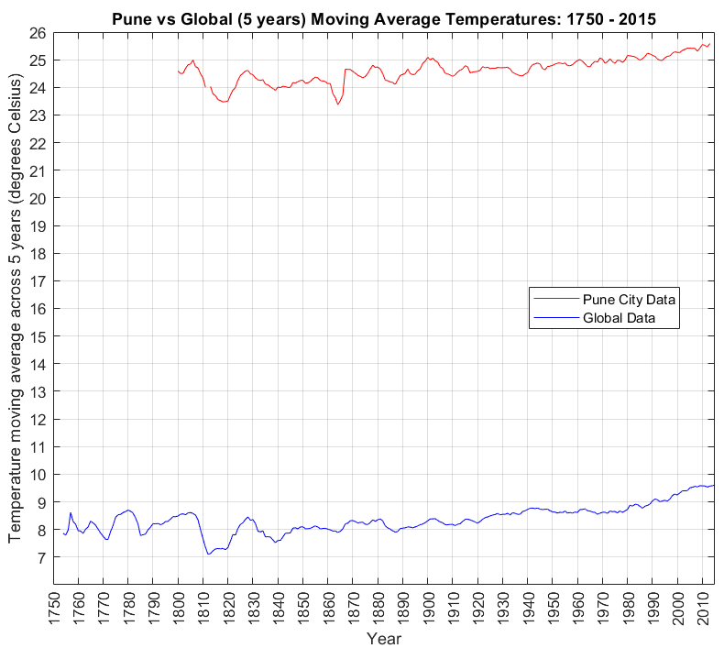

Fig1: Pune vs Global (5 years) Moving Average Temperatures: 1750 - 2015

Key Considerations:

1. Plot both the datasets on a single graph to precisely gauge the correlation between the two
2. Have some degree of continuity in the graph (although is broken at one stage where missing data was present in consecutive time slots). This was achieved by adapting the moving average to accommodate and capture average data for atleast some timestamps for which data was missing.
3. Being able to reuse the same script in order to derive similar observations for other data (not just the city closest to my home town).

Four Observations:

1. The temperature trends seem to move together indicating some degree of correlation between global and Pune city average temperatures. Case in point is the increasing trend of temperatures in degrees Celsius or the dip in temperatures between 1800 and 1830.
2. Towards the beginning of the twentieth century, both Pune city and global average temperatures show an increasing trend rising by nearly 1 ⁰C.
3. There is movement towards a local minima and recovery between 1806 and 1830 in both global and Pune city temperature which may point to a global event that could have resulted in this change (Refer to Little Ice Age from Wikipedia).
4. The global averages (~8.37 ⁰C) are much lower compared to Pune city (24.64 ⁰C) across the reference period available for both of them that sheds light on the latitudinal location of Pune with respect to the Equator.